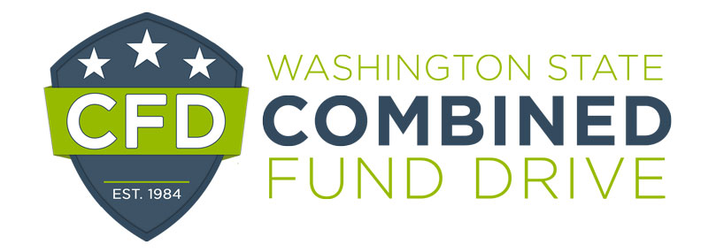

2021 Rookie of the Year Award Nomination Form

The Rookie of the Year Award is presented annually to new CFD coordinators who have gone the extra mile during the Combined Fund Drive campaign. Each agency may nominate their best and brightest coordinators; those who have helped make the CFD campaign a success. (If you have more than one coordinator to nominate in your agency or unit, please consider completing the Outstanding Campaign Team nomination form.)

Please complete the following form. The information you provide will be used to determine award winners and may be highlighted at the annual recognition event. Please be clear and as detailed as possible. The form will expand as you type.

Nominee:

Email and telephone number:

Department:

Supervisor’s name, email, and telephone number:

Your name and title:

Phone number and email:

- Did the coordinator share any goals for the campaign? If so, what were the goals? Were the goals reached? If so, how were they achieved?

- How did the coordinator inspire others to participate in the campaign?

- What activities, events or communications did the coordinator plan for this year’s campaign?

- What made the coordinator’s involvement in the campaign so valuable?

- What do you feel were the most outstanding characteristics of this individual’s campaign efforts?

Please return this form by email to uwcfd@uw.edu by January 12, 2022.

