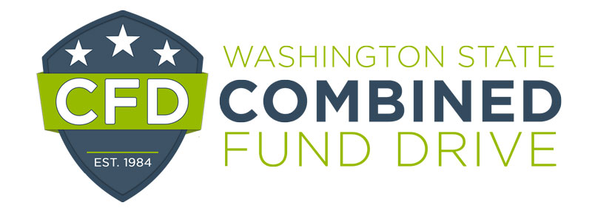

2021 Outstanding CFD Campaign Team Award Nomination Form

This award is presented annually to a group of CFD volunteers that demonstrate exemplary teamwork while promoting and educating employees about the benefits of giving through the CFD.

Please complete the following form. The information you provide will be used to determine award winners and may be highlighted at the annual recognition event. Please be clear and as detailed as possible. The form will expand as you type.

Name of Team:

Agency:

Team Members’ Names:

Email and telephone numbers:

Supervisor’s name, email, and telephone number:*

Your name, title and email:

* CFD wishes to notify the nominee’s supervisor

- In what ways did the team demonstrate teamwork?

- What methods did team members use to raise awareness of the campaign and engage management and staff in the campaign?

- Share how team members displayed positive attributes such as inclusion, good communication, professionalism and respect for colleagues.

- How did the team encourage participation?

- Did the team share any goals for the campaign? If so, what were the goals? Were the goals reached? If so, how were they achieved?

Please return this form by email to uwcfd@uw.edu by January 12, 2022.

