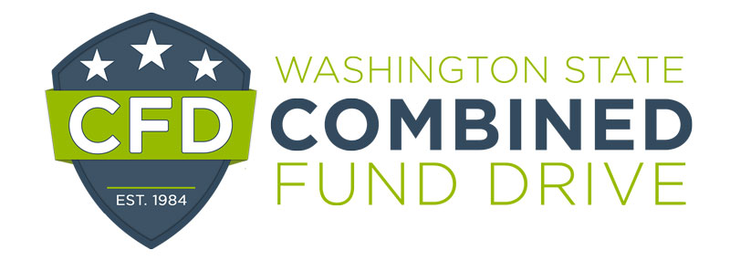
2021 Innovative Event Award Nomination Form

The Innovative Event Award is presented annually to campaign volunteers who demonstrate exemplary outreach and innovation in planning and executing CFD campaign events.

Please complete the following form. The information you provide will be used to determine award winners and may be highlighted at the annual recognition event. Please be clear and as detailed as possible. The form will expand as you type.

Name of the Event:

Agency:

Name of coordinator:

Email and telephone numbers:

Supervisor’s name, email, and telephone number:

Your name and title:

- What was the purpose of the event (i.e., education, charity awareness, increasing payroll deduction, raising money, etc.?)

- Was this an annual or first time event?

- How was the event promoted?

- How many employees were invited to the event and how many attended?

- Were charities invited to participate in the event?

- What made the event remarkable?

Please return this form by email to uwcfd@uw.edu by January 12, 2022.

