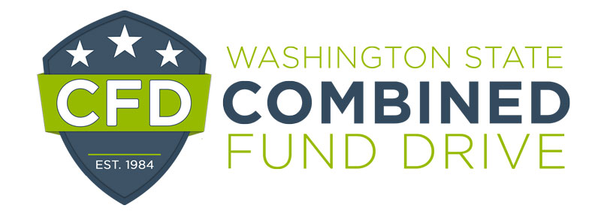

2021 Dean Speer Award for Excellence Nomination Form

The Sno-King Combined Fund Drive Dean Speer Award for Excellence is presented annually to one CFD volunteer who displays the attributes of enthusiasm, professionalism, positivity, outstanding service, and commitment to the UWCFD. Each department/unit may nominate their best and brightest volunteer.

Nominee:
Email and telephone number:
Agency:
Supervisor’s name, email, and telephone number:*
Your name and title:
Phone number and email:

* UWCFD wishes to notify the nominee’s supervisor

Please complete the following form. The information you provide will be used to determine the award winner and may be highlighted at the annual recognition event. Please be clear and as detailed as possible. The form will expand as you type.

1. | In 500 words or less, describe how the nominee displays the attributes of enthusiasm, professionalism, positivity, outstanding service and commitment to the UW Combined Fund Drive. Please provide examples of the volunteer’s interactions, accomplishments, and/or service, and how this individual demonstrates a passion for the UW Combined Fund Drive.  Response:

Please email this form to uwcfd@uw.edu by January 12, 2022.

